In the name of god







***Producers :***

*Sayyed Hossein Hosseini*

***Supervisor :***

*Dr Mohammad Reza Sharbaf*

***Teacher assistant :***

*Reza Pour Mohammadi*

***Faculty of Computer Engineering, University of Isfahan***

***Autumn 2023***

Table of Contents

Work Breakdown Structure1

Define Requirement2

Design3

Build4

Test5

Implement6

Maintenance7

### Work breakdown structure :

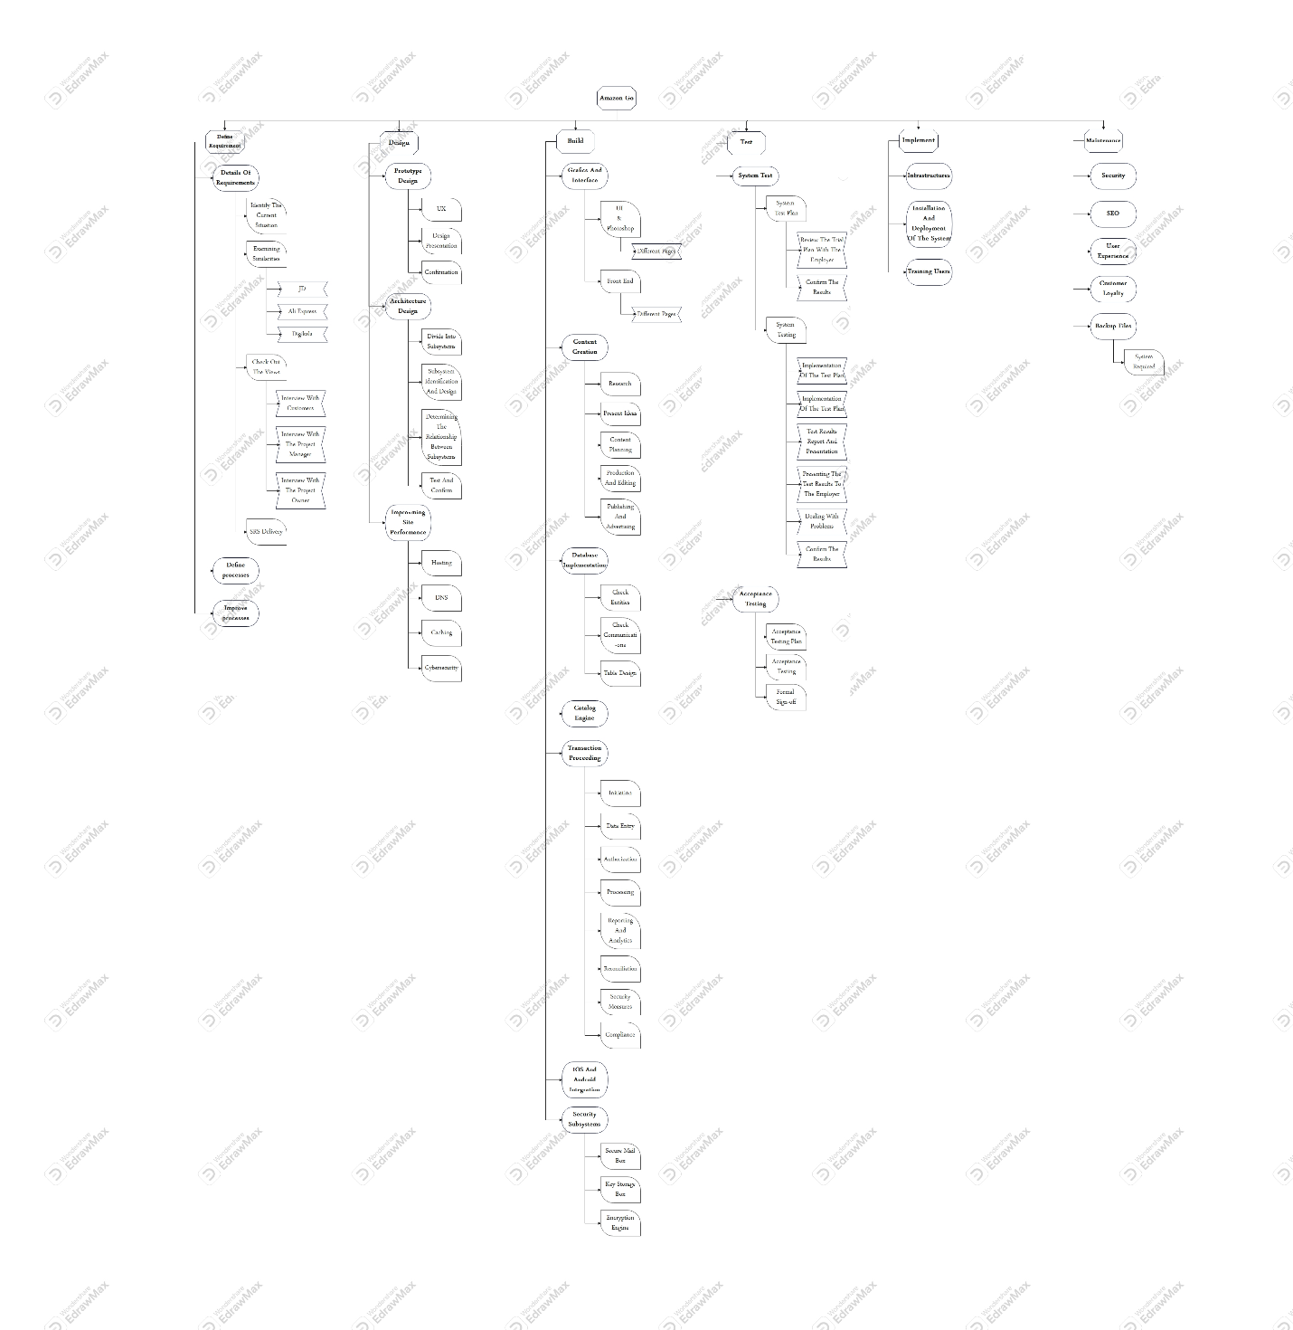

1

### Define Requirement :

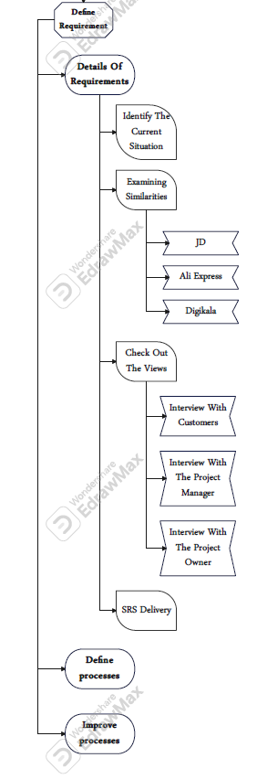

2

### Design :

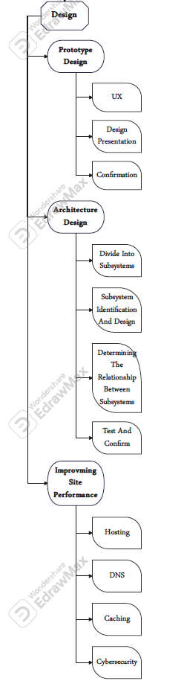

3

### Build :

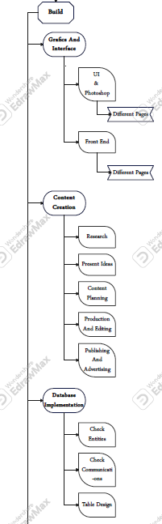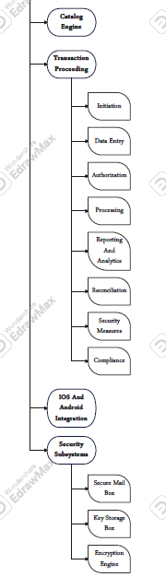

4

### test :

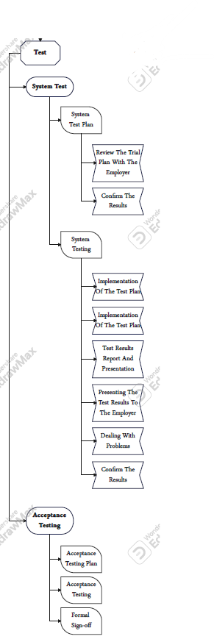

5

### implement :

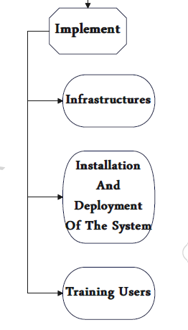

6

### maintenance :

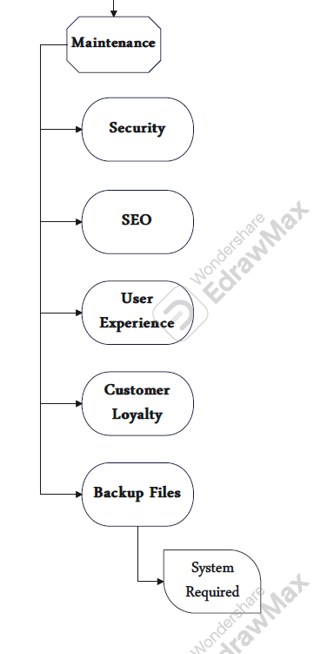

7